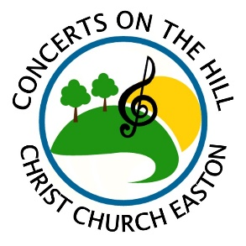
Sponsorship Form for 2022 Concert Series
Please submit this form and payment as soon as possible.
Questions? Call 203-268-3569 or email concertsonthehilleaston@gmail.com.

Any sponsorships will be advertised online & on Facebook, as well as other print media that deadlines have not yet passed.

NAME OF BUSINESS or INDIVIDUAL (as it should appear on all acknowledgements):
___________________________________________________________________________________________________________
ADDRESS: ___________________________________________________________ PHONE: ______________________________
EMAIL: ____________________________________________ WEBSITE: ______________________________________________
For business sponsorships: Authorized by (please print name): ________________________________________________________
DESCRIPTION of business (1-2 sentences - for Facebook posts): ______________________________________________________
___________________________________________________________________________________________________________
___________________________________________________________________________________________________________
Choose from the following sponsorship levels:
___ $50 – Friend
Includes two free tickets to a concert(s) of your choosing and a shout-out on our Facebook page

___ $100 – Silver
Includes four free tickets to a concert(s) of your choosing and a shout-out on our Facebook page

___ $300 – Gold
Sponsor one concert! Max: two gold sponsors per concert. Includes six free tickets (redeemable at any 2022 concert) as well as a mention on our Facebook page, Facebook event & press release (if submitted by 5/3). Optional: display promotional materials and/or a banner or sign at the concert. (All materials must be provided by you).
Requested Concert Date: _______

___ $1,000 – Platinum
Sponsor the entire 2022 concert series! Includes all Gold Level perks, plus an additional six free tickets and premier placement on all our advertising. (An $800 savings compared to sponsoring 6 concerts each at the gold level!)
Instructions:
Mail this form and a check made out to “Christ Church” to: 59 Church Rd, Easton, CT 06612.
Or email this form to concertsonthehilleaston@gmail.com and pay online at www.christchurcheaston.com (click “Donate” button).

All sponsorship payments are a tax-deductible donation.
A receipt with will be mailed to the address you provide above.

About Concerts on the Hill:
Set on the scenic grounds of Christ Church Easton, this outdoor concert series has quickly become a local community favorite since its inaugural season in 2017, averaging 200 people at each concert. 2022 season dates: 6/19, 6/26, 7/3, 7/10, 7/17, 7/24.,7/31 8/7, 8/14. Gates: 5:30 pm. Music: 6:00-8:00 pm. Craft beer/wine, food trucks, or BYOB & picnic! Rain dates TBA. $7 adults, $5 seniors, kids 18 & under free.
More Info: www.facebook.com/concertsonthehilleaston

